An Evaluation of Cover Crop Seeding Rates and Planting Dates
Cooperative Extension•Delaware State University
Cover Crops can produce many environmental and agricultural benefits including reducing erosion, compaction, weed pressure and run-off and increasing soil organic matter, Nitrogen fixation, biodiversity, soil moisture, and captured nutrients. Delaware’s Natural Resources Conservation Service (NRCS) offers subsidies to farmers to plant cover crops to promote environmental benefits including a decreased nutrient flow into the watershed and bays.
Purpose
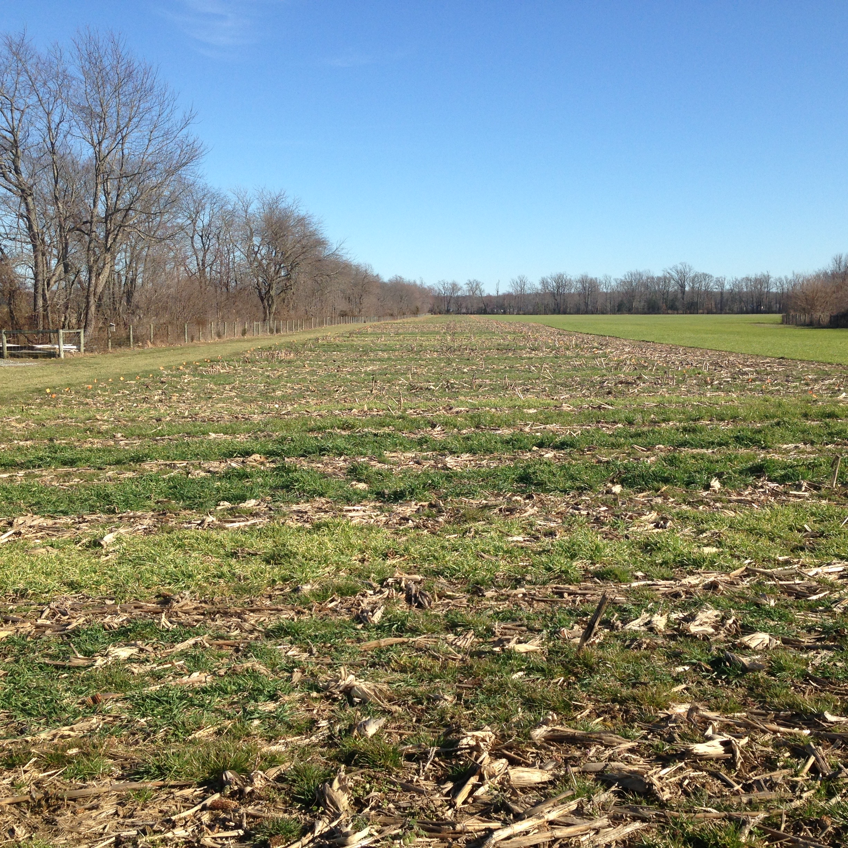
NRCS cover crop subsidies require planting at specific seeding rates and by specific dates to ensure adequate ground cover, and biomass. Many farmers have been telling NRCS that they are unnecessarily strict, causing them to waste money on extra seed, and limit their ability to meet deadlines because of their cash crops.
Treatments
4 cover crop varieties: Wheat, Barley, Rye, and a Clover (at 12 bu/acre)/rye mix
3 seeding rates: High (2 bu/ac), Medium (1.5 bu/ac), Low (1 bu/ac)
3 Planting dates: Early (September 30), Standard (October 13), and Late (October 30)
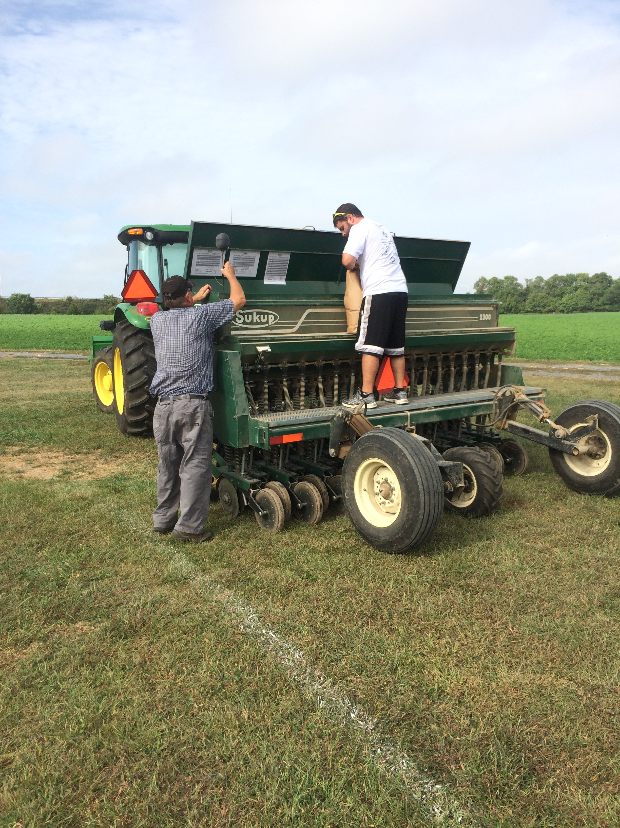
2 Seeding Methods: Broadcast and drilled using a no-till grain drill
72 Treatments replicated 3 times for a total of 216 5’X50’ plots, separated by 5’ gaps

Data Collection
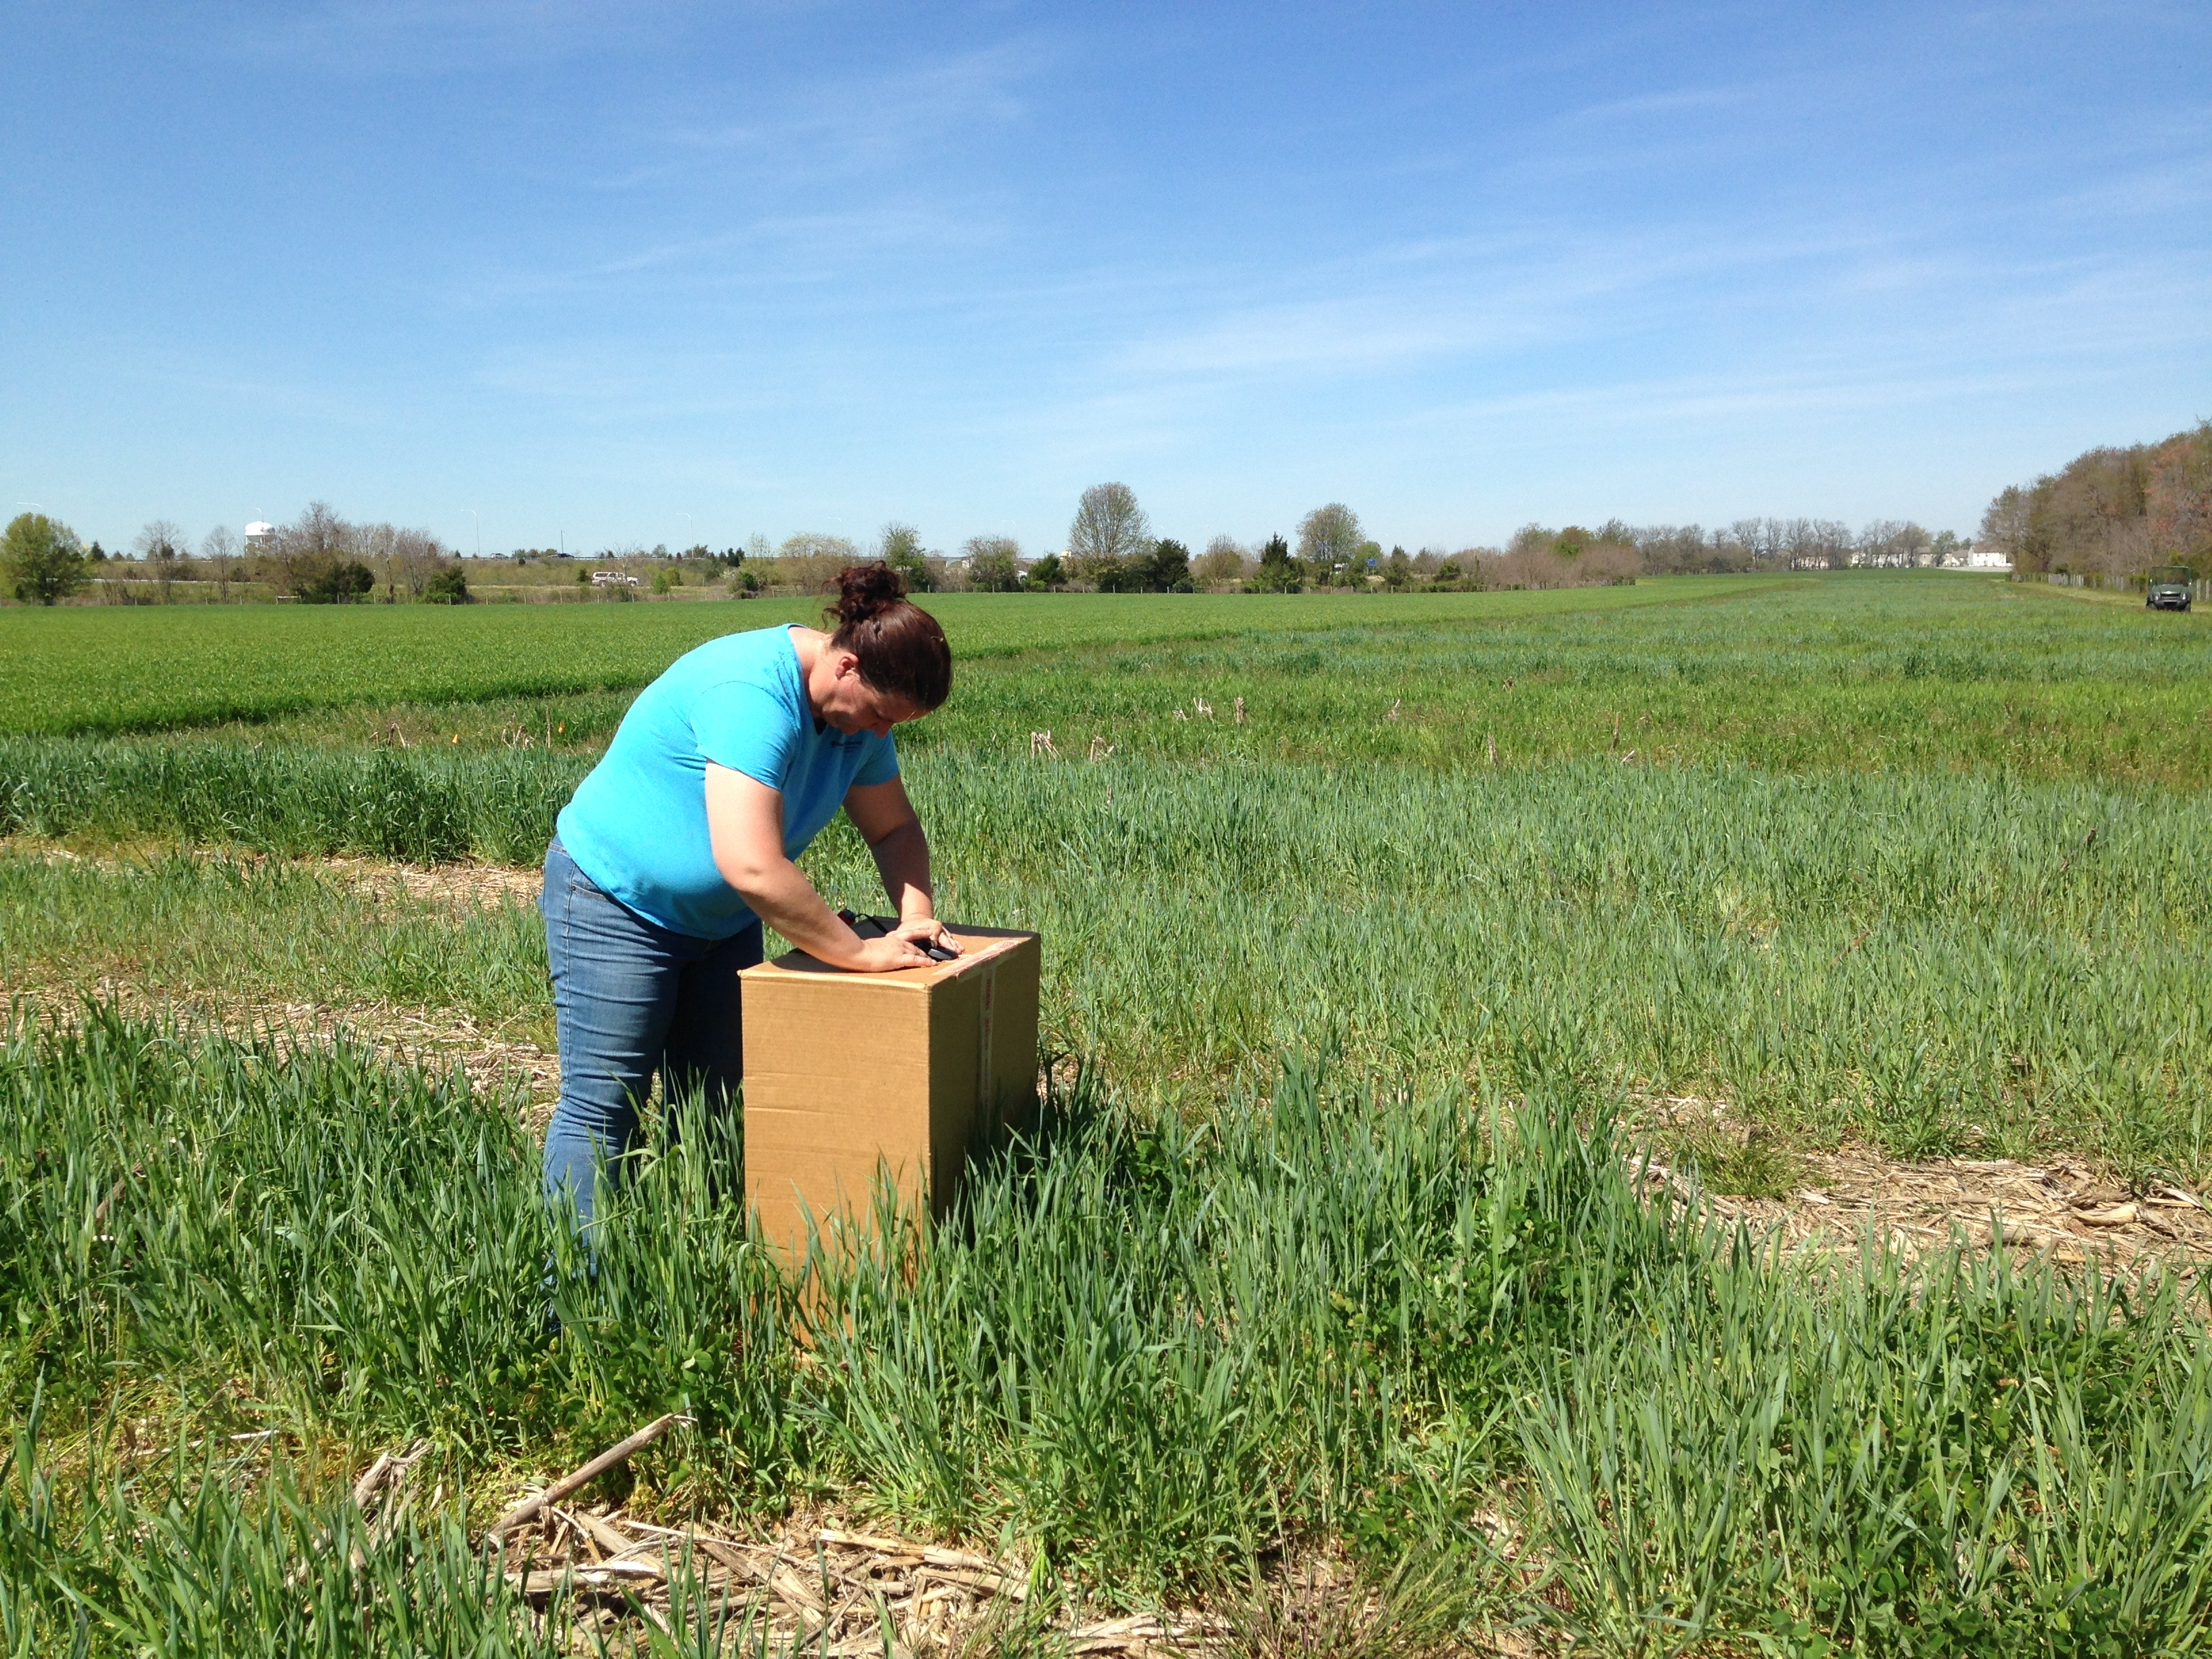
Fall Establishment and Ground Cover
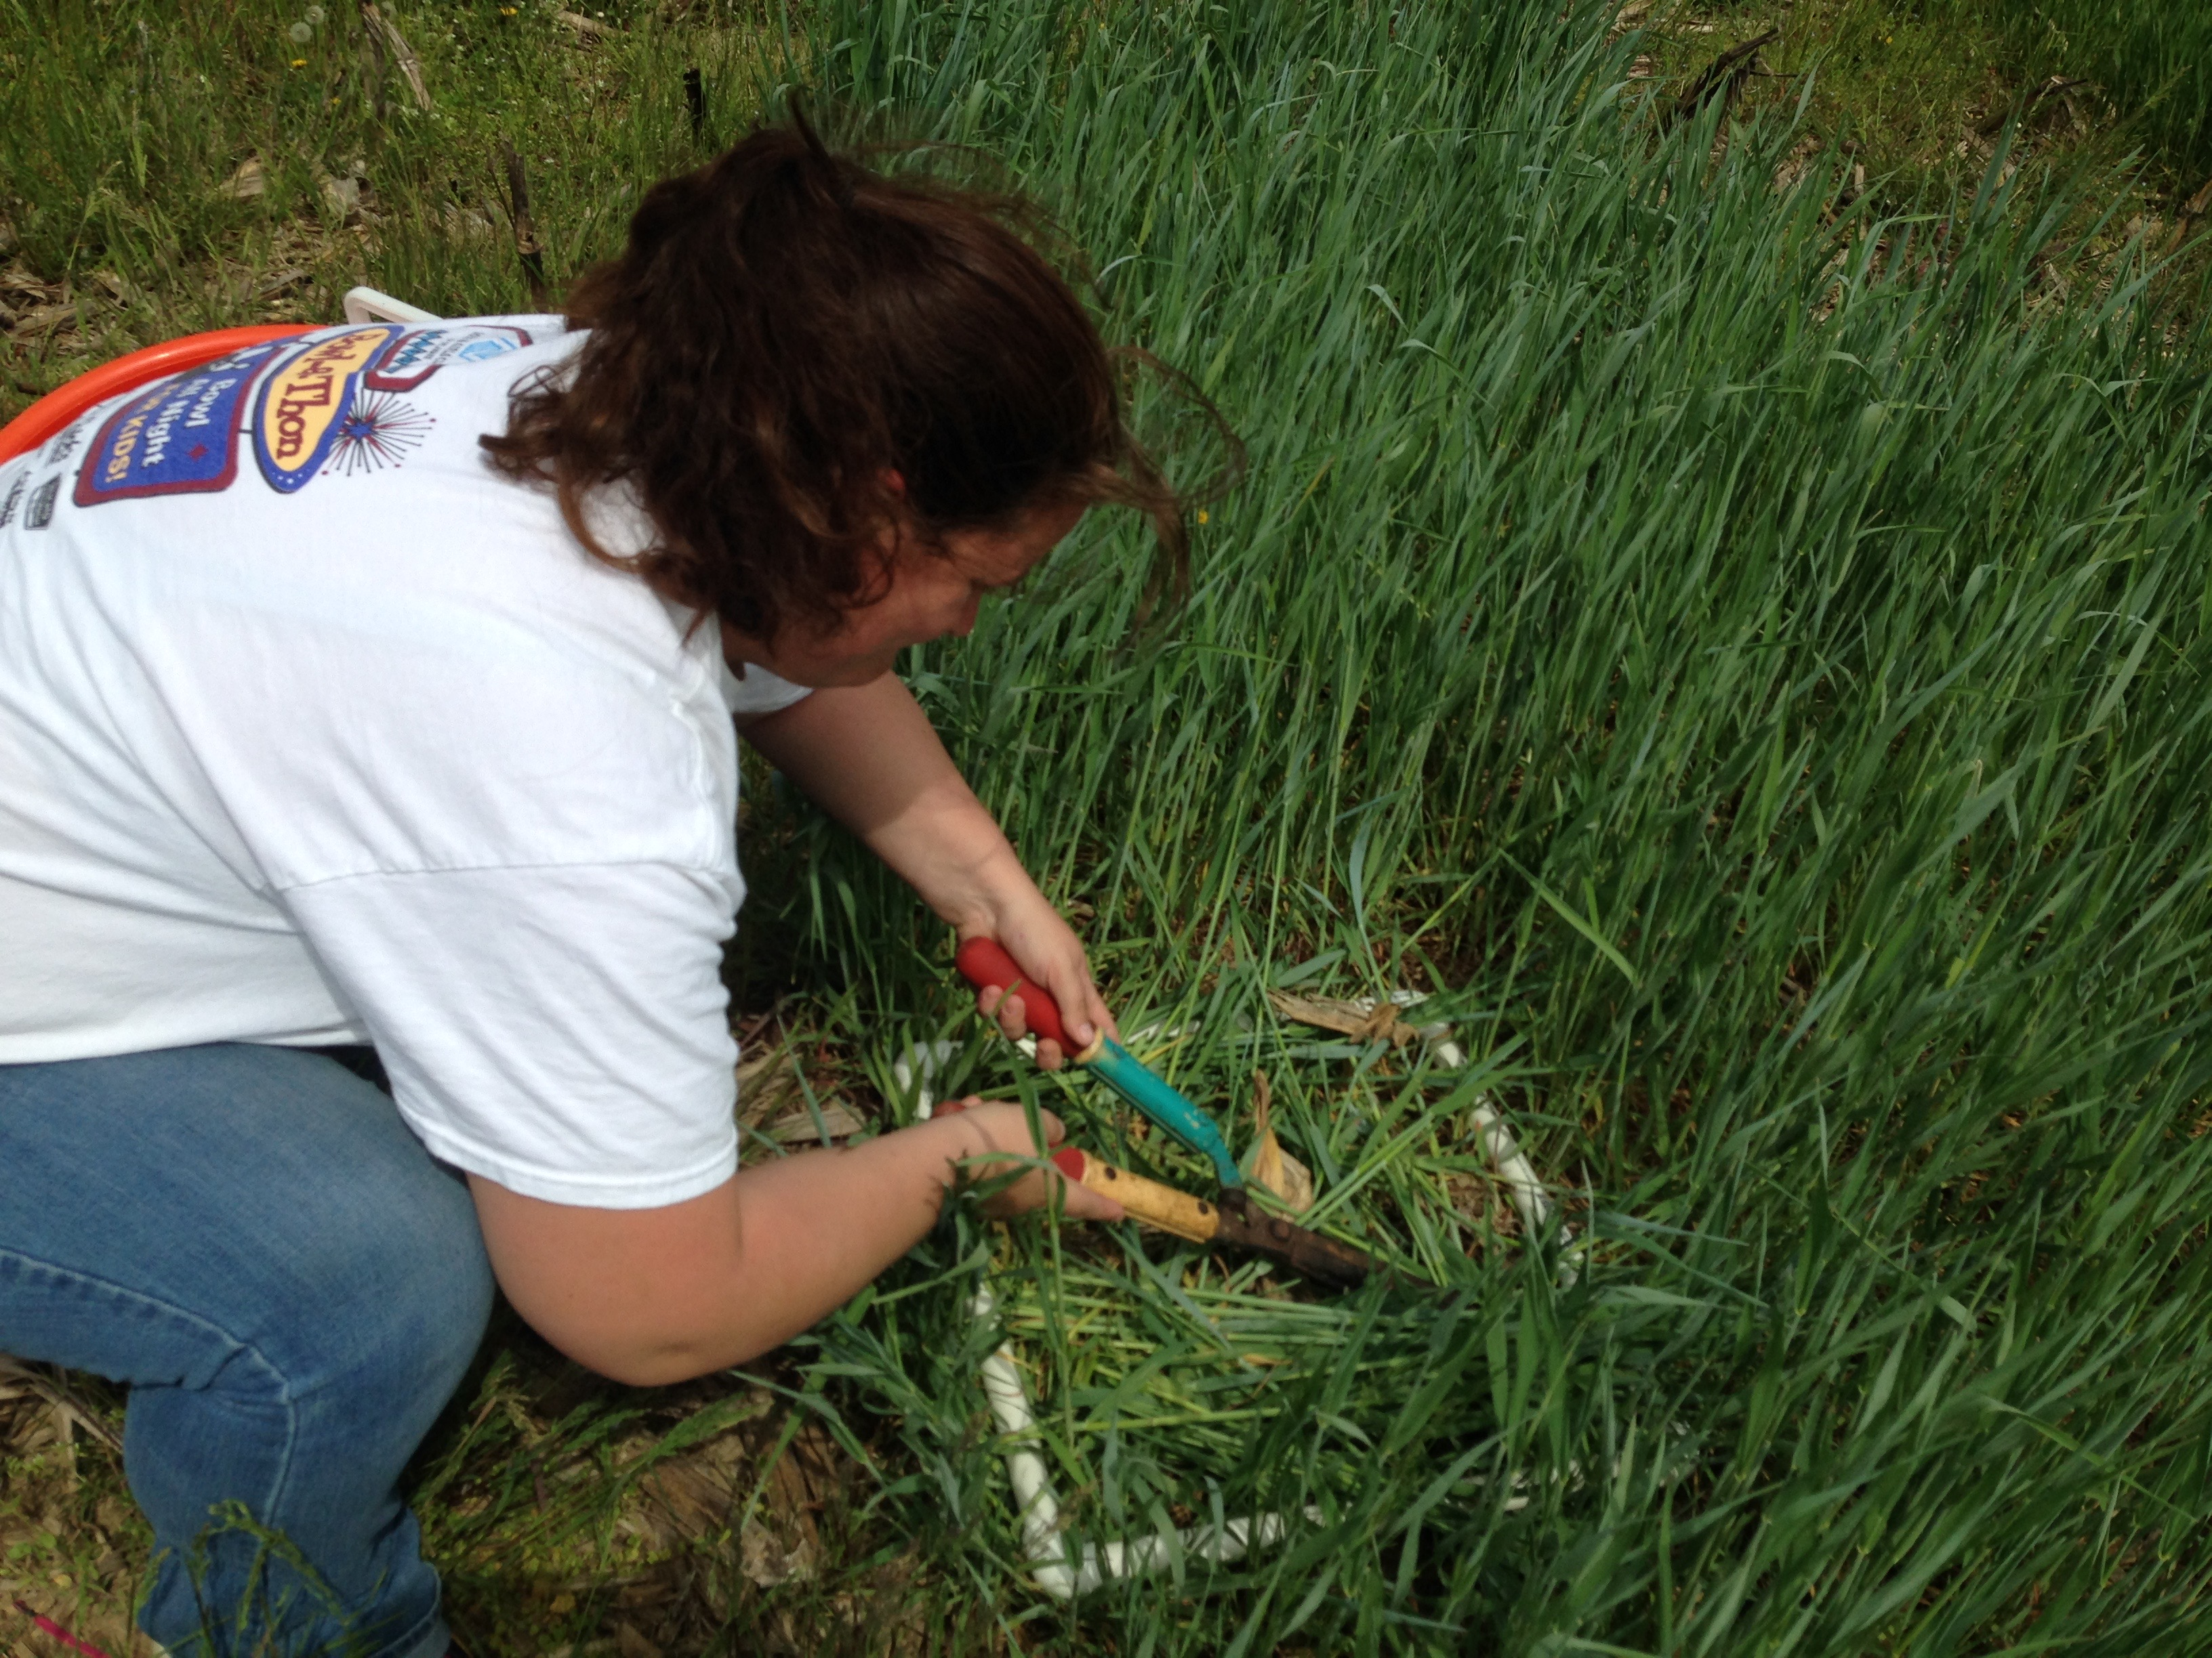
Percent Ground Cover was measured by taking photos of each plot in December using a “Light box” , which were analyzed in the Canopeo Ap.
Biomass
In Spring, biomass was measured by cutting 2 1.5’X1.5’ representative samples from each plot, which were then dried and weighed.

Results
Fall ground cover
Barley, rye, and rye/clover had significantly more ground cover than wheat
At the standard planting dates, drilled had more cover than broadcast, but they were similar for the other dates
The early date had more ground cover than standard, which had more than late.
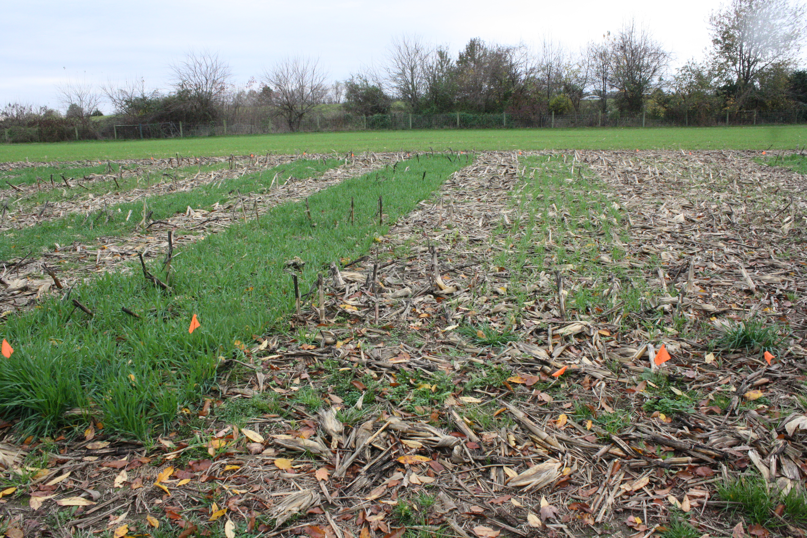
Biomass
Drilled plots had significantly more biomass than broadcast.
The early date had more biomass than the standard date, which had more biomass than the late date.
Seeding rate had a minimal effect on biomass
For barley, rye, and rye/clover, the early and standard dates produced more biomass than the late.
For Wheat, the early date produced more biomass than the standard and late dates.
Recommendations based on this year’s data:
To maximize ground cover and biomass, it is important to plant by the standard NRCS planting date of October 15.
Planting by the early date produced more ground cover that the standard, but not more biomass.
Lowering seeding rates may have a minimal effect on biomass or ground cover, but this cannot be done under current NRCS subsidy guidelines.
Drilling can produce more biomass, but the seeding method does not affect ground cover.
Wheat is slower to establish than the other crops and had a lower ground cover percentage. To get more wheat biomass, plant by the early planting date.
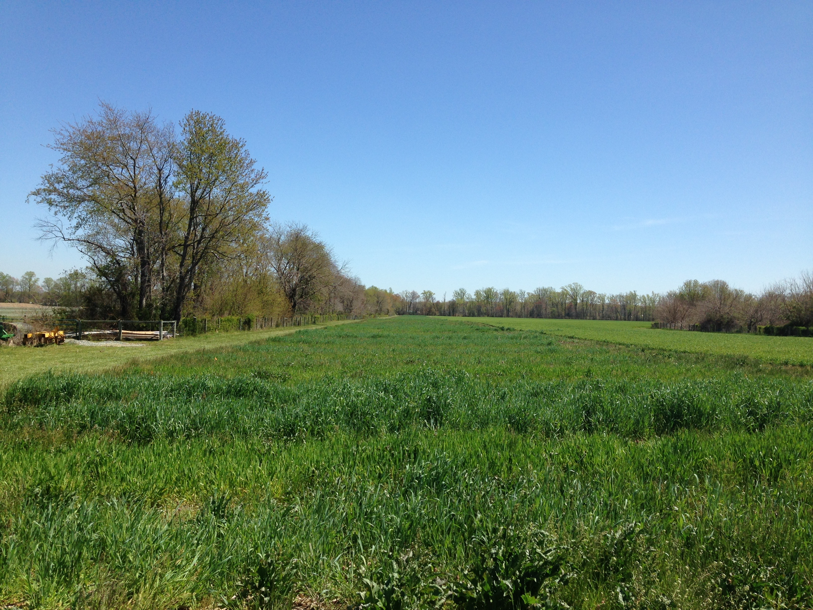
For more information, contact Jason Challandes, the Regional SARE Educator at jchallandes@desu.edu.

Cooperative Extension Education in Agriculture, 4-H and Home Economics, Delaware State University, University of Delaware and United States Department of Agriculture cooperating, Dr. Dyremple B. Marsh, Dean and Administrator. It is the policy of Delaware Cooperative Extension that no person shall be subjected to discrimination on the grounds of race, color, sex, disability, age, or national origin.

